**2-5 Milestone Project Proposal**

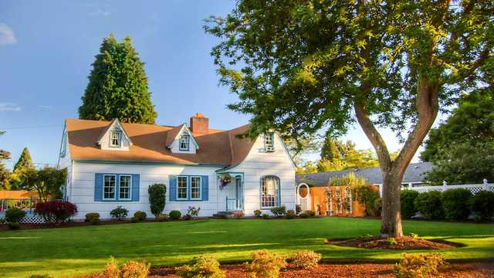

Since I selected a house in the initial explanation of the 2D scene into 3D objects, I will stick with it. In my opinion, a house is a good starting point when learning OpenGL and trying to recreate the scene into simple 3D shapes. The items I will try to recreate are of course the house, the ground, and the tree. The ground consists of grass primarily and that is what I will incorporate into my project. It will be a plane with a grass texture on which the house and a tree will be created. The tree will consist of One main cylinder as a base and 2 other cylinders that will split as in the picture. On the top, I will use two spheres which will be the leaves and branches. The house will consist of the most geometrical shapes. The base of the house will consist of a parallelepiped and a cube. The roof will be made of the main triangular prism, and other smaller triangular prisms, and the chimney will be made of parallelepiped. The windows and the door will be made of planes with the textures of those items. As a new designer with OpenGL, I believe these goals are achievable and interesting to work with. This is a great step towards getting better at OpenGL and a perfect learning opportunity for a newbie like me.